IEEE BASED agricultura and irrigational BASED

PROJECTS

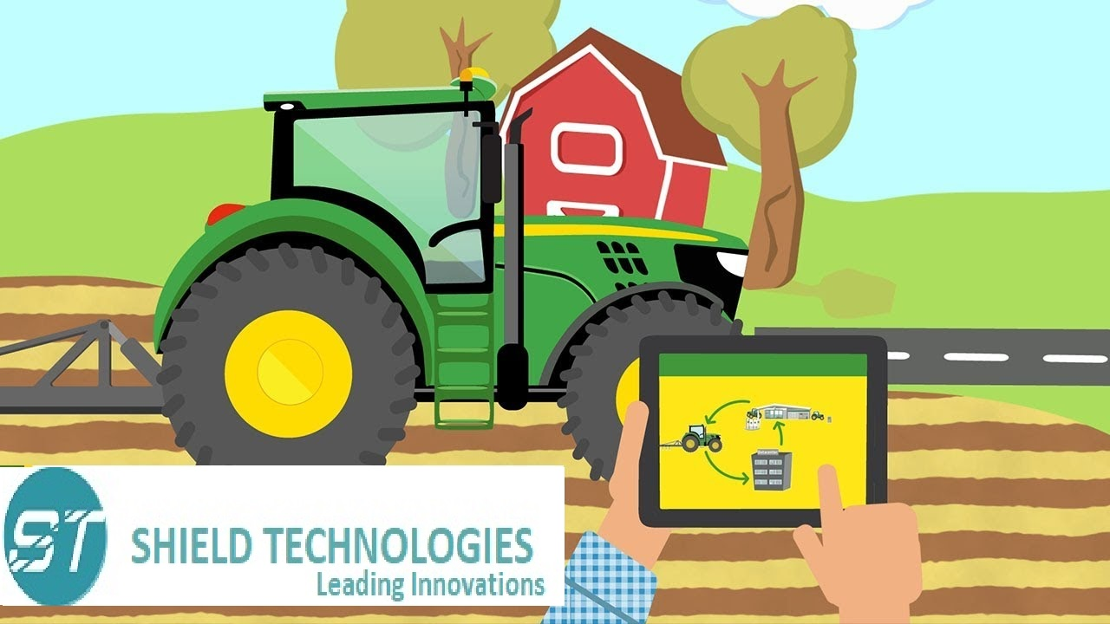

sl no | TITTLE
STAI001 | DESIGN AND FABRICATION OF SUGARCANE HARVESTER USING SAW CHAIN  (SOLAR OPERATED
STAI002 | FABRICATION OF ADVANCED 5 IN 1 MULTI PURPOSE AGRICULTURAL ROBOTIC VEHICLE (AGRIBOT)
STAI003 | FABRICATION OF SOLAR IRRIGATION
STAI005 | FABRICATION OF WHEEL CARRIED PESTICIDE SPREYER
STAI007 | FABRICATION OF MULTI PURPOSE TOOL DRIVEN MACHINE ( DIGGING, PLOUGHING, LEVELING)
STAI008 | FABRICATION OF AUTOMATIC SEED SOWING MACHINE
STAI009 | FABRICATION OF SEED SOWING MULTI ROBOTS ( SWORM ROBOTS )
STAI010 | FABRICATION OF COCONUT TREE CLIMBING ROBOT
STAI11 | FABRICATION OF REAL TIME MAIZE SEED SEPARATOR
STAI12 | DEVELOPMENT OF PADDY HARVESTING MACHINE ( RUBBER ROLERS)
STAI13 | FABRICATION OF SOLAR SEED DRYER
STAI14 | FABRICATION OF HYDRAULIC 3 AXIS MODERN TRAILER
STAI15 | WATER PUMPING SYSTEM USING WIND POWER
STAI16 | FABRICATION OF SOLAR SEEDS SPRAYER
STAI17 | SYSTEM FABRICATION OF REAL TIME ADVANCED 5 IN 1 MULTI PURPOSE AGRICULTURAL VEHICLE – AGRI VEHICLE

